
[Document title]
[Document subtitle]

[Date]
[Company name]
[Company address]

ALGORITHM DESIGNS
Flow Charts

Log In

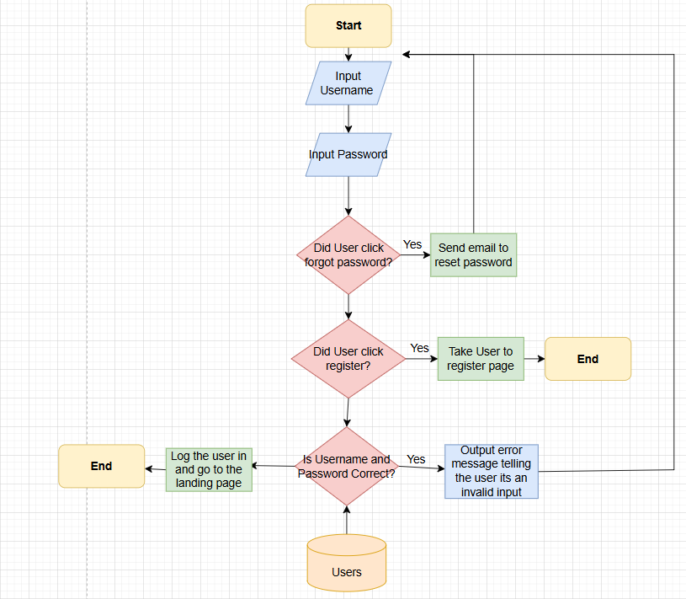
The user will be prompted to input their username and passwords then the system will check if the user has made actions like clicking forgotten password, if this is the case the system will send a password reset email to the user. If the user clicks the register button the system will redirect them to the register page. If the user doesn’t click any of those the system will check if the password and username is valid, if its not the system will output an error message that the user log in info is in invalid thus sending them back to re-enter their log in info. If the user information is correct the system will log the user in and redirect them to the home page.

Register

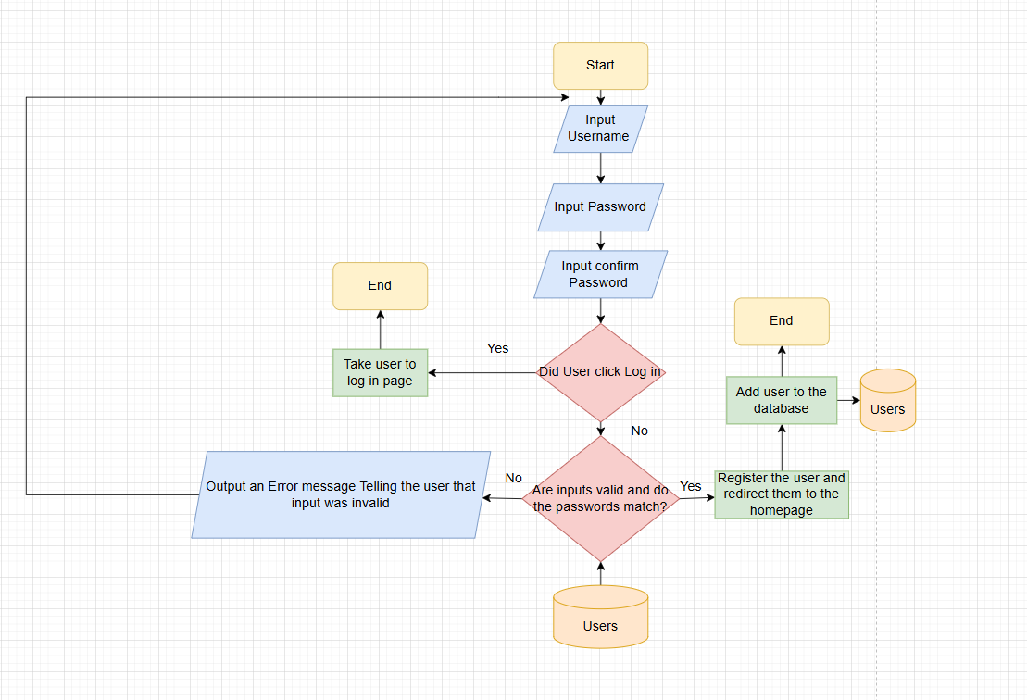
The user will be prompted to input their username and password and also to confirm the password. If the User interacts with the log in button, the system will redirect the user to log in page. If not then the system will check if the user inputs were valid. If the inputs were not valid the system outputs an error message informing the user that the input is invalid and prompts them to re-enter their log in details. If the inputs were valid then the system registers the user and adds them to the database.

Place an Order

